How do Museums Turn Black and White Photos into Color Pic for Better Touring Experience

Nothing could beat the charm of a picture with exquisite colors and transparency. Many studies have proved how colors could influence a person's mood. When you stare at a picture, and your eyes skim an image, its colors will automatically enhance your creativity, productivity and brain development.

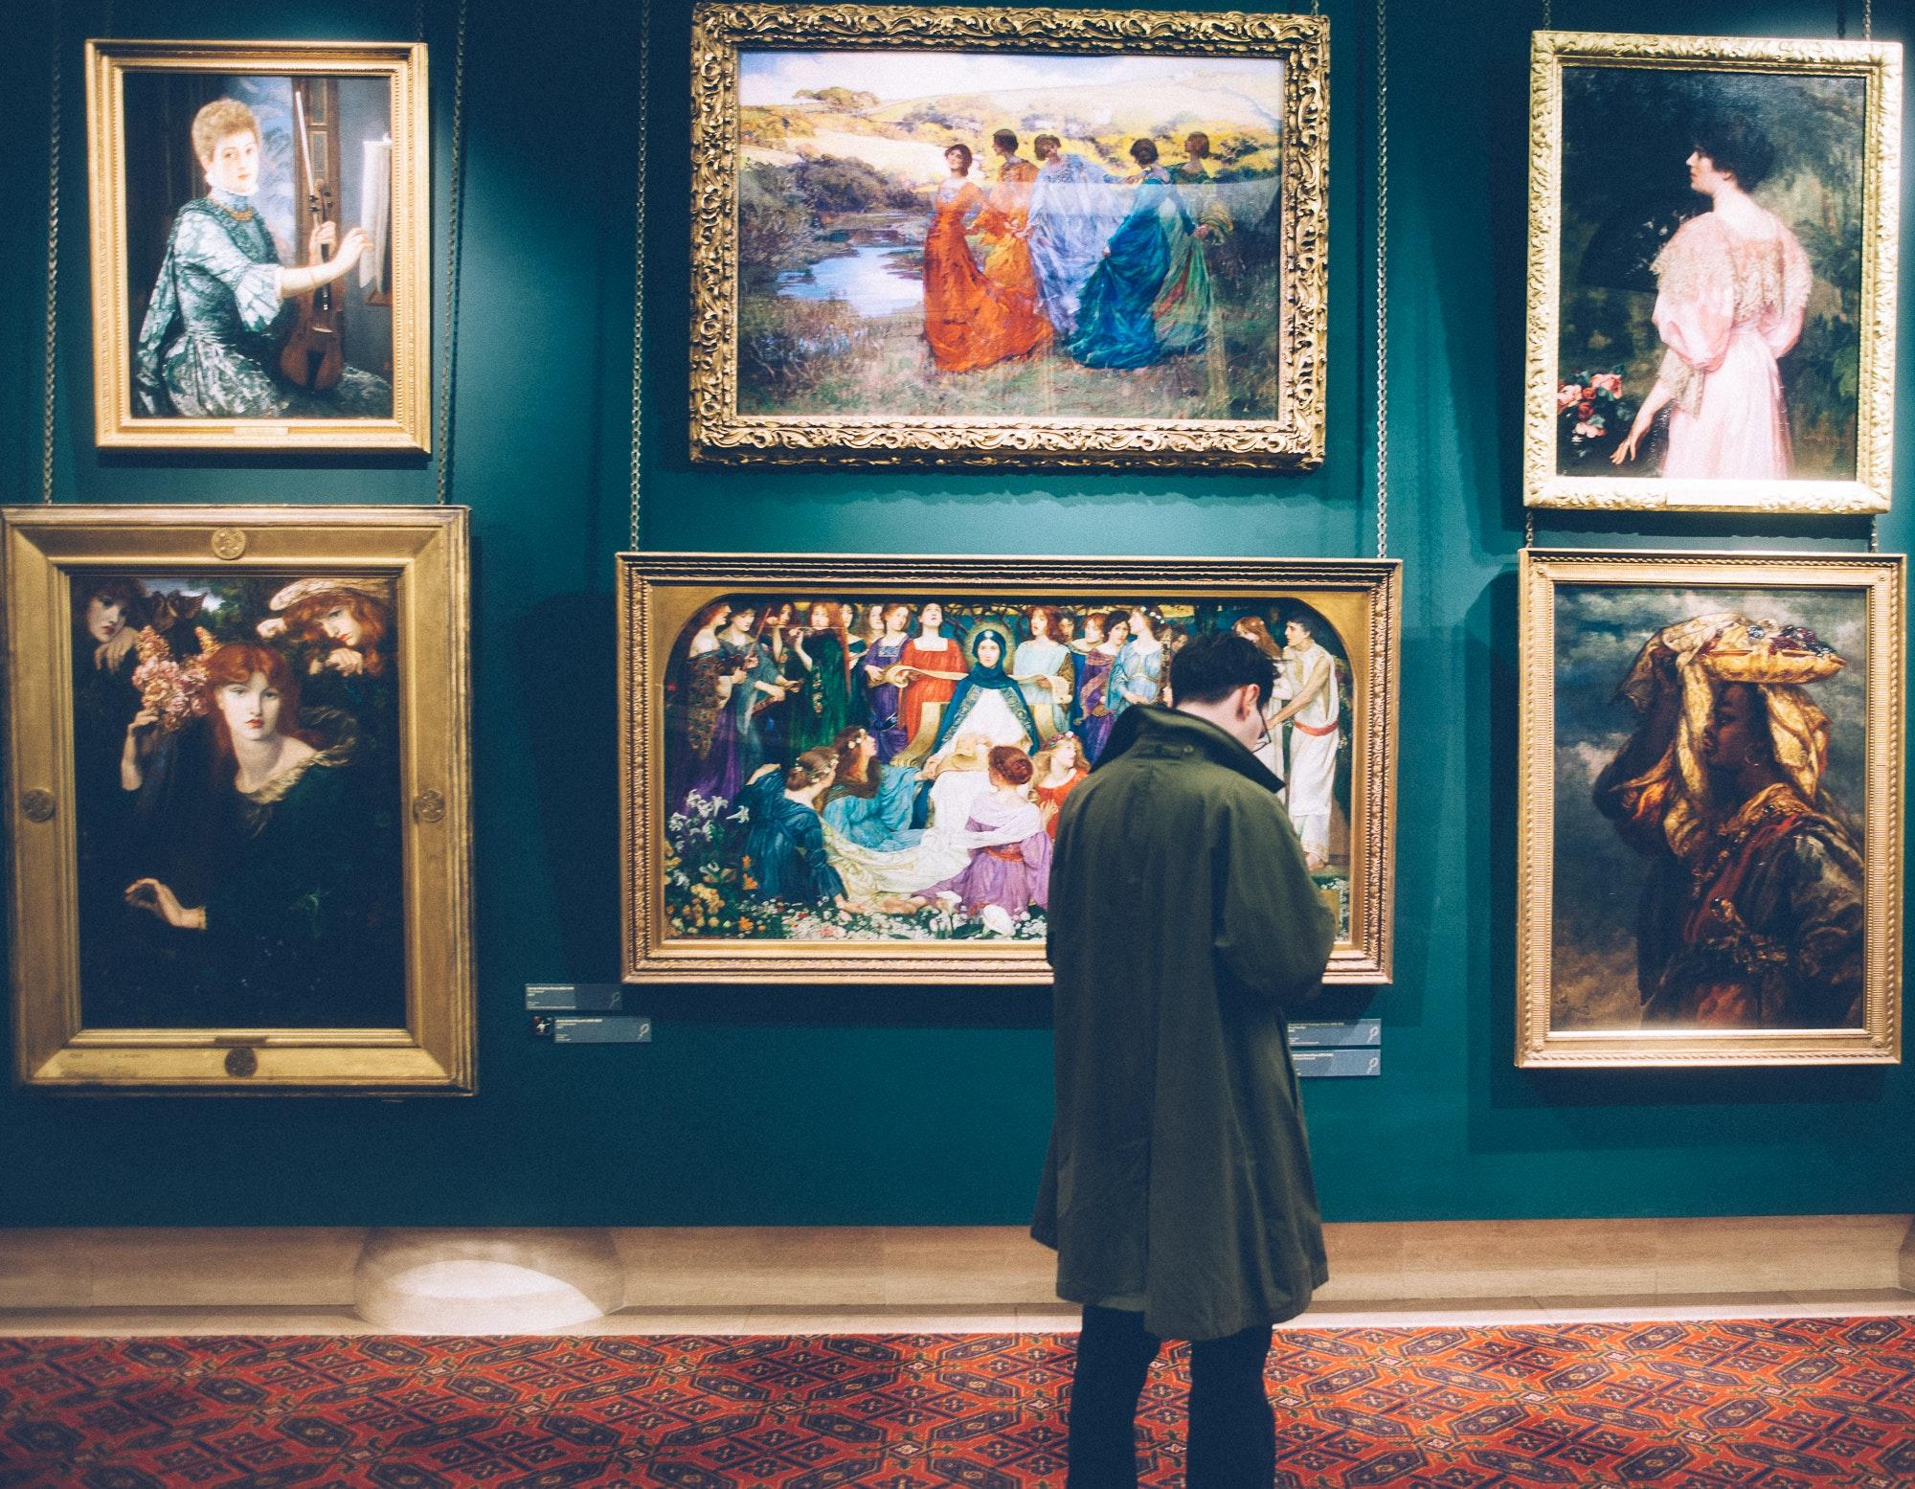

Museums around the globe have been trying very hard to increase their visits by colorizing their images by hiring different artists and paying a heavy amount of money. Imagine owning an art gallery and putting all of your efforts into creating a masterpiece but still not getting your target audience. Museums have also been facing such issues. The flair of hand painting or coloring black and white photos is a method museums employ for a very long time. However, this method might not prove as helpful. Natural degradation might cause decolorizing of the beauty of the image over time.

## Issues With Manual Enhancing/Coloring

There are some of the problems those hand-coloring causes. Firstly, photos might not end up looking naturalistic. Secondly, they might lose accuracy. Thirdly, artists cost a bulk of money. Fourthly, artists might not offer a warranty. Fifthly, hand painting cannot remove signs of ageing of the image. Sixthly, artists might fail to persuade the audience. Lastly, they cannot upscale the images or denoise them.

There is a significant base for museums to look for artificial intelligence photo editing software. Artificial intelligence owns the digital capability to remodel anything creative in the blink of an eye. Museums should target innovative results rather than spending a large sum on hiring the artists or wasting hours on laborious manual editing of images.

Here is a list of the best AI software that allows museums or any other department (photography, designing, photo editing or digital art) to do things with just one click. These software can simplify previously arduous tasks in a fraction of a second. For instance, colorizing black and white photos, animating images, image up scaling, fixing blurry photos, etc.

There are numerous techniques to apply AI software to enhance or denoise photos. Some software tends to perform all tasks together while others focus on a single function at a time. If you are looking for the tools that are handy and do magic, there could be no better option than cutout.pro. It provides you all-in-one tools that just need one click to perform the action.

To colorize Black and White images cutout.pro provides you with the tools that can provide the best results.

## Photo Colorizer

Photo Colorizer by cutout.pro is one of the best tools that practice artificial intelligence to color black and white photos, which museums can use to increase visitors. This tool yields magnificent results by bringing images to life. Other tools might not be easy for lay people because they demand technical knowledge. However cutout.pro has got your back. It constructed easy-to-use colorizing tools for everyday use. It colorizes the photo in the best way possible and provides you with natural results. It removes all the faults in the picture, makes skin look perfect and colors the pic in an original way.

**Before**

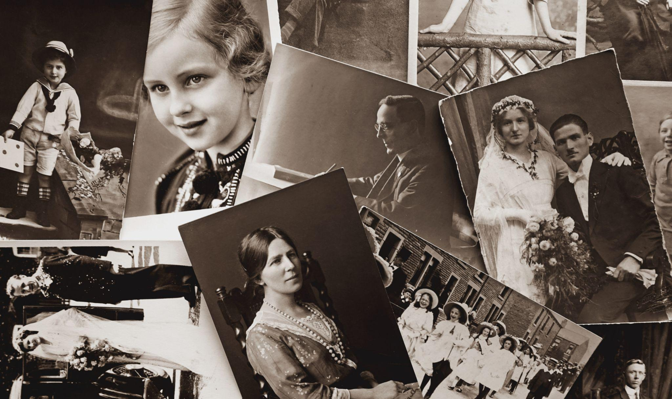

**After**

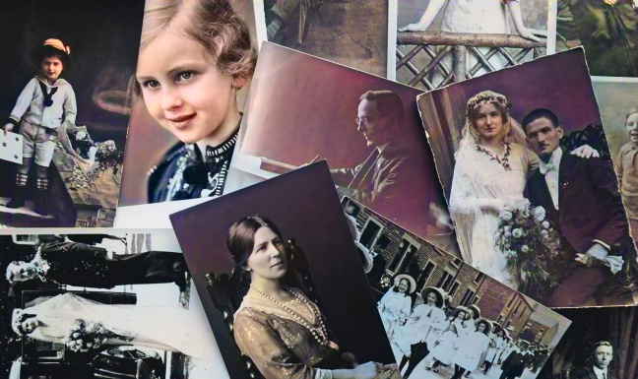

## Photo Enhancer

With Photo Enhancer by cutout.pro, it’s time to say good-bye to the traditional manual tools. Photo Enhancer is the best tool that uses artificial intelligence to deblur or fix old images or blurry photos. Museums can also use Photo Enhancer to improve the audience experience in the museums. There are many AI tools that you can use to enhance photos but, cutout.pro assembles everything in just one tool that performs the magical job. It not only enhances the dead photos but also assists you in achieving the best version of that image. The results this tool provides are hyper-real. It makes the image so smooth that one could identify his ancestors or hero in the history. With this tool, you can denoise photo and also enjoy the service of image upscale

## Photo Animer

You could spend a lot of money on creating visual art but still have to struggle with communicating your message. In this regard cutout.pro has got you covered to animate the photos. Photo Animer by cutout.pro is a tool that does wonders to your images. Museums can get animated images to increase the audience's interest in infrequent visits by using Photo Animer. Photo Animer also works with Artificial Intelligence.

Museums can make ancient poets, writers, warriors, heroes, and other personalities smile, wink or blink by animating photos with the help of this tool. This tool does not require a lot of effort. All you need to do is upload the image and leave the rest to artificial intelligence to do the magic. It will take a fraction of a second to animate the photo. Animated images not only interest kids but also adults or elders, which will lead to significant increase in the visits.

## MyHeritage in Color

MyHeritage in Color is an updated version of other AI tools. This tool also uses AI to colorize or enhance the photo. It not only colors the pic but also fixes blurry photos. Museums can use it for multiple purposes, that is, colorization or color restoration. If one took the colored image in the past, MyHeritage in Color would restore the colors, and if the image is already black and white, you can colour the pic according to your choice. This app permits one to create a site where one can set up their family tree. One of the best things about this picture is that it offers a free trial for the first ten images.

Museums can leave behind all the laborious tasks with the photo enhancing tool of MyHeritage. It provides the best service. It deblurs and enhances blurry photos. Museums can use this tool to upscale images, sharpen the ancient images and freshen up the memories related to that image. It performs the entire job in just one click.

## Bottom Line

Many digital companies kept using expensive and laborious methods to perform their tasks. However, Artificial Intelligence has made things easier for everyone. It allows one to perform many hours worth of tasks just in seconds. None of the AI tools is ideal, but their results are eye-opening most of the time. Same is the case with the tools of cutout.pro. It provides you with the best and convincing results.